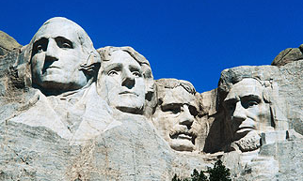

7:00 Open

Call to Order

7:30 Citizen Comments

Approval of Minutes

Appointments

7:35 Economic Development Committee - Update

Old Business

- Budgets

New Business

Close the Warrant for Special and Annual Town Meeting

Upcoming Meetings

Announcements

Adjournment

Executive Session – Pending Litigation and Collective Bargaining

